一年前险些破产，蔚来会成为中国的特斯拉吗？

2020.12.05

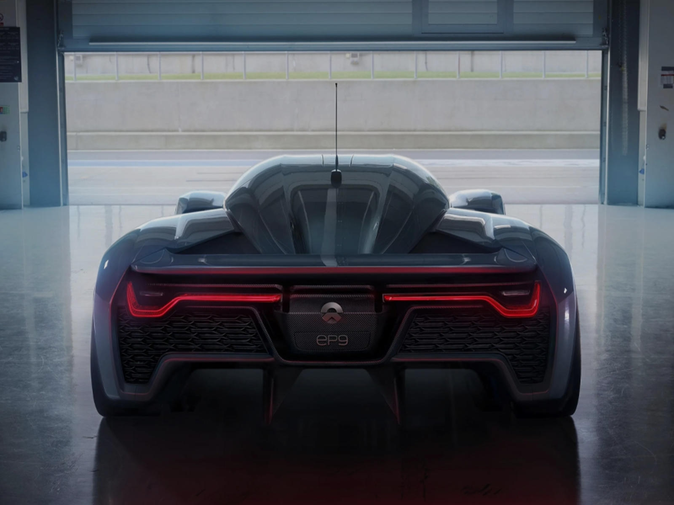

**How NIO, a Chinese EV Startup, Rose, Fell and Rose Again**

**蔚来汽车是如何在走下神坛后重新崛起的**？

A year ago, Chinese electric-vehicle startup NIO Inc. was near ruin. Today it is worth more than General Motors Co..

NIO’s brush with bankruptcy and its subsequent revival to become the world’s fourth most valuable auto maker — only Tesla Inc., Toyota Motor Corp. and Volkswagen AG are worth more by market capitalization — is a measure of investors’ seesawing faith in Chinese EV startups, which for years promised a high-tech automotive revolution that proved elusive.

From its founding in two thousand and fourteen, NIO led a pack of Chinese EV startups that became a magnet for investors seeking the next Tesla. But many investors eventually lost confidence, frustrated by the loss-making companies’ limited progress.

A savior arrived: the government of Hefei, a city about three hundred miles west of Shanghai in Anhui — the home province of Mr. William Li, NIO’s founder and chief executive — that has emerged as a center of EV production. NIO agreed to a six hundred and eighty three million dollars financing package with the city’s officials in April.

The capital injection rescued NIO, chiefly by giving suppliers and customers confidence that the company had a future, Mr. Li said.

Mr. Li said NIO aims to produce seven thousand five hundred cars a month starting in January; it contract-manufactures its vehicles in Hefei. It plans to start selling cars in Europe next year — and eventually in the U.S. .

译文：

一年前，中国电动汽车初创企业蔚来汽车濒临破产。而如今，它的市值却超过了通用汽车公司。

蔚来曾与破产擦肩而过，后来又崛起为全球市值第四高的汽车制造商，市值仅次于特斯拉、丰田汽车公司和大众汽车，这种巨变恰恰凸显出投资者对中国电动汽车初创企业的信心起伏不定。多年来，中国的电动汽车初创企业一直承诺将带来一场高科技汽车革命，但事实证明这仍未能完全实现。

自2014年成立以来，蔚来成为一批中国电动汽车初创企业的领军者，这些初创企业吸引着希望发掘下一个特斯拉的投资者。但由于这些企业持续亏损并且进展有限，许多投资者最终失去了信心。

救星来了，那就是合肥市政府。合肥市位于上海以西约300英里，是蔚来创始人兼首席执行官李斌的家乡安徽省的一座城市。安徽省已成为电动汽车的一个生产中心。今年4月，蔚来与该市官员达成了6.83亿美元的融资协议.李斌表示，这次注资拯救了蔚来，主要因为这让供应商和客户相信该公司仍有前途。

李斌还表示，蔚来汽车计划从明年1月开始月产能将达到7,500辆；该公司采用代工模式在合肥生产电动汽车。他们计划明年开始在欧洲销售电动汽车，最终进军美国市场。

生词好句

1.NIO

蔚来（取意a new day；蔚蓝天空，美好未来）

2.electric vehicle

电动汽车

3.startup

英 [ˈstɑːt ʌp] 美 [ˈstɑːrt ʌp]

n. 新成立的公司（a newly established business）

4.near

英 [nɪə] 美 [nɪr]

prep. 接近于某种状态（close to a state）

拓展:

常见用法：near或者near to后跟名词

The old man was near (to) death.

这位老人快要离世了。

I was near (to) tears at one point during the film.

看到电影中某个情节时，我几乎要泪奔。

5.ruin

英 [ˈruːɪn] 美 [ˈruːɪn]

n. 破产，一无所有，失去所有金钱及其他财产（the complete loss of one’s money and other assets）

拓展:

The divorce led to his ruin.

离婚使得他一贫如洗。

6.a brush with sth.

（几乎）经历过（某种情况）

拓展:

brush UK /brʌʃ/ US /brʌʃ/

n. 与......的短暂相遇（a brief encounter with someone or something unpleasant or notable）

a brush with death 与死神擦肩而过

my first brush with fame 我的首次成名

7.subsequent

英 [ˈsʌbsɪkwənt] 美 [ˈsʌbsɪkwənt]

adj. 随后发生的（following）

拓展:

Subsequent events confirmed our doubts.

后来发生的事证实了我们的怀疑。

8.revival

英 [rɪˈvaɪvəl] 美 [rɪˈvaɪvəl]

n. 复活，复苏（back to life）

拓展:

前缀"re"表示：回（back），例如return v. 返回（turn back）。

词根"viv"表示：活着的（live），例如survive v. 幸存，继续活着。

后缀"al"是名词后缀。

an economic revival 经济复苏

9.incorporated

英 [ɪnˈkɔːpəreɪtɪd] 美 [ɪnˈkɔːrpəreɪtɪd]

adj. 股份有限的

10.corporation

英 [ˌkɔːpəˈreɪʃən] 美 [ˌkɔːrpəˈreɪʃən]

n. （大）公司

11.AG

股份公司（德语词汇缩写，英文译文为stock corporation）

12.market capitalization

（公司的）市值（指一家上市公司的发行股份按照当前的市场价格计算出来的股票总价值）

拓展:

capitalization

UK /ˌkæpɪtəlaɪˈzeɪʃən/ US /ˌkæpətələˈzeɪʃən/

n. 资本总额

13.measure

英 [ˈmeʒə] 美 [ˈmeʒər]

n. 衡量标准（a basis or standard of comparison）

拓展:

Wealth is not a measure of happiness.

财富不能作为衡量幸福的标准。

14.seesaw

英 [ˈsiːsɔː] 美 [ˈsiːsɑː]

vi. 上下来回摇动；n. 跷跷板

15.elusive

英 [iˈluːsɪv] 美 [iˈluːsɪv]

adj. 难以实现的（difficult to achieve）

拓展:

Success will become ever more elusive.

成功变得越来越渺茫。

16.a pack of

一群（相似的人或物）（a group of similar things or people）

拓展:

A pack of journalists was waiting outside the White House.

一群记者在白宫外等着。

17.package

英 [ˈpækɪdʒ] 美 [ˈpækɪdʒ]

n. 一整套的想法或服务（a set of ideas or services that are suggested or offered all together as a group）

拓展:

package deal 一揽子交易

a package of measures to help small businesses 扶助小商家的整套措施

18.capital injection

注资（指为某个项目或某项事业投入数量较大的资金）

19.chiefly

英 [ˈtʃiːfli] 美 [ˈtʃiːfli]

adv. 首要地（most importantly）

20.contract-manufacture

按合同制造生产

拓展:

contract manufacturer 合同制造商（CM）

合同制造商是一类专门根据客户提供的特定标准为客户生产产品的制造企业。

原文：

How NIO, a Chinese EV Startup, Rose, Fell and Rose Again

By Trefor Moss

@The Wall Street Journal

A year ago, Chinese electric-vehicle startup NIO Inc. NIO -6.43% was near ruin. Today it is worth more than General Motors Co. GM -2.71%

NIO’s brush with bankruptcy and its subsequent revival to become the world’s fourth most valuable auto maker—only Tesla Inc., TSLA -3.10% Toyota Motor Corp. and Volkswagen AG VOW 2.89% are worth more by market capitalization—is a measure of investors’ seesawing faith in Chinese EV startups, which for years promised a high-tech automotive revolution that proved elusive.

From its founding in 2014, NIO led a pack of Chinese EV startups that became a magnet for investors seeking the next Tesla. But many investors eventually lost confidence, frustrated by the loss-making companies’ limited progress.

By 2019 China had 635 EV startups on paper, according to the government-backed NEV State Monitoring Center. Few had produced a single car and most looked doomed as government subsidies and private financing evaporated.

NIO’s demise looked set to be the most spectacular of all.

Once feted in the local media as “China’s Tesla killer,” the company lost $3.67 billion between 2017 and 2019 while selling fewer than 32,000 cars. NIO shares, worth about $10 when the company went public, sank to $1.39 late last year as investors fled.

“We called it an extreme stress test,” said William Li, NIO’s founder and chief executive, recalling last year’s crisis in an interview. The company’s troubles started, he said, when the U.S.-China trade war deterred American investors from subscribing to NIO’s 2018 initial public offering on the New York Stock Exchange. The company raised half the $2 billion Mr. Li had been hoping for, scrambling his financial plans.

A costly battery recall then strained NIO’s finances further, as did a surprise downturn in the Chinese auto market, during which EV sales declined 4% in 2019.

An exodus of senior executives followed, as Shanghai-based NIO slashed its global head count by a quarter to fewer than 7,500 staff members. That included job losses at its American office in San Jose, Calif.

As it entered a make-or-break phase in late 2019, NIO had one advantage that most other startups lacked, according Mr. Li—it was actually selling cars, with the roughly 8,000 vehicles it delivered in the fourth quarter of last year generating $400 million in precious cash flow.

“That was very important to us because at that point we had no other financing channels,” said the 46-year-old.

Even so, auto analysts said NIO was weeks away from failure unless it could find a white knight.

A savior arrived: the government of Hefei, a city about 300 miles west of Shanghai in Mr. Li’s home province of Anhui that has emerged as a center of EV production. NIO agreed to a $683 million financing package with the city’s officials in April.

The capital injection rescued NIO, chiefly by giving suppliers and customers confidence that the company had a future, Mr. Li said.

Since then, NIO’s shares have rallied, topping $57 on Nov. 25 before falling back slightly. As of Friday, the company had a market capitalization of about $73.6 billion, still well short of Tesla’s $555 billion valuation.

Aside from its own restructuring efforts, the company’s rally is also thanks to Tesla, which has stoked China’s EV market since starting production in Shanghai late last year. Tesla sold more than 72,000 locally built Model 3 sedans in the six months to October, according to the China Passenger Car Association.

Other EV companies have accelerated in Tesla’s slipstream. NIO sold more than 24,000 vehicles in the same six-month period and topped 5,000 monthly sales for the first time in October.

Like Mr. Musk, Mr. Li is a serial entrepreneur, having founded or made major investments in more than 40 companies. As a boy, he herded cattle with his farmer grandparents in Anhui province. He went on to attend the prestigious Peking University in the nation’s capital.

A sociology major who says he did better in his computer science classes, Mr. Li co-founded his first company—a kind of data center—while in college. In 2000, he founded BitAuto, an automotive services portal that was listed on the New York Stock Exchange from 2010 until earlier this month, when shareholders took the company private.

Often seen in polo shirts, jeans and sneakers, Mr. Li is estimated to be worth more than $8 billion, according to Forbes.

Mr. Li said NIO aims to produce 7,500 cars a month starting in January; it contract-manufactures its vehicles in Hefei. It plans to start selling cars in Europe next year—and eventually in the U.S.—Mr. Li said.

It is aiming to outflank Tesla and others with a battery-swap system that enables NIO drivers to switch batteries within a couple of minutes rather than waiting hours to recharge.

While battery swapping potentially solves the charging issue that deters many consumers from buying EVs, it requires NIO to build a costly network of spots where drivers can swap their batteries. It has built 162 such stations so far.

The company is also giving customers the option of buying a car minus the battery. That reduces the cost of NIO’s ES6 sport-utility vehicle from about $52,200 to $41,600, though customers would then pay a $150 monthly fee to rent a battery. A third of NIO buyers are now choosing this rental option, Mr. Li said.

NIO still has its detractors. Earlier this month short seller Citron Research said NIO shares had become overvalued and dismissed investor enthusiasm for Chinese EV startups as “mania.” NIO’s share price has kept rising, however.

Mr. Li defended his company’s high valuation relative to that of traditional auto makers. They still produce far more cars than NIO, he said, but for nuts-and-bolts manufacturers “it would be difficult to adapt to an era where the car is defined by software.”

Reprinted by permission of The Wall Street Journal, Copyright 2020 Dow Jones & Company, Inc. All Rights Reserved Worldwide.

Original Date of Publication: Nov. 30, 2020