2021届高考英语一轮复习易错题型专训（10）
图画作文

1.假设你是红星中学高三学生李华。下面四幅图描述了你在家做饭时发生的小意外。请根据以下四幅图的先后顺序,用英语写一篇日记,记述你处理意外的全过程。
​注意:词数不少于60。
提示词:煤气炉 gas stove;锅铲 cooking shovel
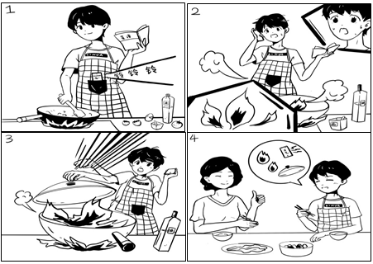
___________________________________________________________________________________________________________________________________________________________________________________________________________________________________________________________________________________________________________________________________________________________________________________________________________________________________________________________________________________________________________________________________________________________________________________________________________________________________________________________________________________________________________
2.假设你是红星中学高三(1)班学生李欢,请根据以下四幅图的先后顺序,写一篇英文日记,记录你班同学上周六参观中国科学院的全过程。
注意:词数不少于60.
提示词:中国科学院 Chinese Academy of Sciences
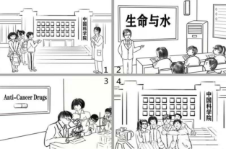
___________________________________________________________________________________________________________________________________________________________________________________________________________________________________________________________________________________________________________________________________________________________________________________________________________________________________________________________________________________________________________________________________________
3.假设你是红星中学高三学生李华。请根据以下四幅图的先后顺序,写一篇英文周记,记述你与同学参与“红十字急救培训”活动的全过程。
注意:词数不少于60。
提示词:救护员证first aider certificate
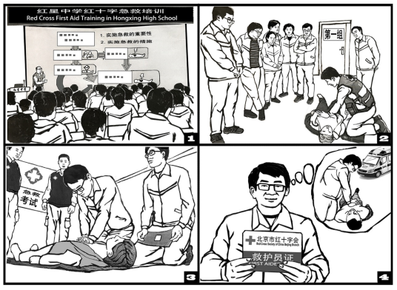
______________________________________________________________________________________________________________________________________________________________________________________________________________________________________________________________________________________________________________________________________________________________________________________________________________________________________________________________________________________________________________________________________________________________________________________________
4.假设你是红星中学高三学生李华。上周,你们班参加了学校的“爱科学月”板报展活动。 请根据以下叫幅图的先后顺序,写一篇英文周记,记述整个过程。
注意:词数不少于60。
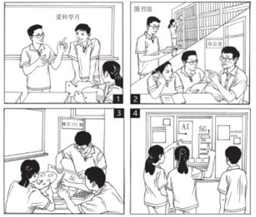
5.假定你是李华。你从你校国际部的招募海报得知美国高中生代表团要来你市和你校参观和交流,希望找一名在校高中生做志愿者向导。请你根据海报内容给学校国际部写一封邮件应聘志愿者。​
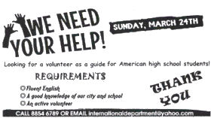
注意:
1.词数80左右;
2.可以适当增加细节,以使行文连贯。
___________________________________________________________________________________________________________________________________________________________________________________________________________________________________________________________________________________________________________________
6.假设你是红星中学高三学生李华,为校刊英语园地写一篇题为“Our Spring Outing” 的英文稿件。 请根据以下四幅图的先后顺序,叙述上周你们班从准备春游到春游结束的完整过程。
注意: 词数不少于60.
提示词: 游乐园 amusement park 垃圾箱 bin
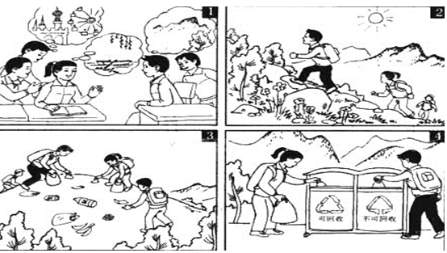
________________________________________________________________________________________________________________________________________________________________________________________________________________________________________________________________________________________________________________________
7. 假设你是红星中学高三学生李华,请根据以下四幅图的先后顺序,写一篇英文周记,记录毕业前夕你们制作以“感恩母校”为主题的毕业纪念视频的全过程。
​ 注意:词数不少于60。
提示词:视频video
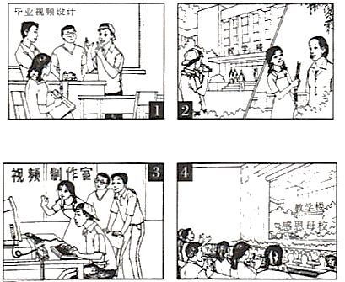
______________________________________________________________________________________________________________________________________________________________________________________________________________________________________________________
8.假设你是红星中学高三学生李华,请根据以下四幅图的先后顺序,写一篇英文周记,记述你们上周接待外国学生,带领他们体验中国茶文化的全过程。
注意:词数不少于60。
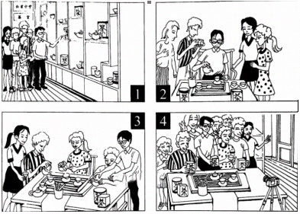
______________________________________________________________________________________________________________________________________________________________________________________________________________________________________________________

答案以及解析
1.答案：
One day, when I was cooking on the gas stove at home according to the cook book, my phone rang.【高分句型一】 (做饭的时候电话响起) I answered the phone without turning off the gas. Suddenly, the pan caught fire, which made me frightened. (锅着火了)It occurred to me that the fire will go out without air. The moment I covered the pan with the lid, the fire went out. 【高分句型二】(盖上锅盖)When my mother heard what happened, she praised me for my bravery and cleverness.(妈妈夸奖作者)
解析：高分句型一:One day, when I was cooking on the gas stove at home according to the cook book, my phone rang.
译文:有一天,当我在家里用煤气炉做饭的时候,我的电话响了.
分析:when引导时间状语从句.
高分句型二:The moment I covered the pan with the lid, the fire went out.
译文:我一盖上锅盖,火就熄灭了.
分析:the moment引导时间状语从句.
2.答案：
One possible version:
Last Saturday, my classmates and I went to the Chinese Academy of Sciences, which was a precious chance/golden opportunity to get close to science.
The moment we arrived at the Chinese Academy of Sciences, we were warmly greeted by a friendly expert standing at the entrance. Excited and happy, we clapped our hands and everyone was eager to explore the amazing scientific world. To have a better understanding of daily basic science, we attended a professional lecture themed Life and Water. A professor introduced the topic in such great detail that we all gave full attention and took a lot of notes.
The highlight of the visit was the hands-on experience in the science lab. Under the guidance of the expert, we got involved in a medical experiment with great care and enthusiasm. Observing the samples through the microscope, we, for the first time, got to know how anti-cancer drugs were developed and what awesome achievements our hardworking scientists had made. We also felt proud of the medical progress of our country.
Before we left, we invited the expert to take a group photo with us as a reminder of the fantastic visit, everyone wearing a big smile. Through the meaningful activity, we all agree that science plays an important role in our life and we will study hard to take advantage of it to make our world a better place.
解析：写好这类作文要注意几个步骤:
1. 认真审题,找准提示语中的关键词或句,确定中心思想.
2. 依据关键句,草拟提纲,梳理文章的脉络
3. 准确定位人称、时态.注意使用高级词汇和高级句型使文章显得更有档次.
4.最后还要认真查验是否有漏写情况,有无拼写错误及标点误用等
高分句型一:Last Saturday, my classmates and I went to the Chinese Academy of Sciences, which was a precious chance/golden opportunity to get close to science.
本句是which引导的非限定性定语从句;
意为: 上周六,我和我的同学去了中国科学院,这是一个接近科学的宝贵机会/黄金机会.
高分句型二:A professor introduced the topic in such great detail that we all gave full attention and took a lot of notes.
本句是that引导的定语从句;
意为: 一位教授如此详细地介绍了这个话题,以至于我们都给予了充分的关注,并做了很多笔记.
3.答案：
One possible version:
Last week, I took part in the Red Cross first aid training.
At the beginning, we assembled in the school hall to listen to the importance and basic steps of first aid. After realizing how important first aid is, we couldn’t wait to learn more. After a short grouping, we were led to a classroom where a trainer demonstrated the detailed procedure. We watched closely as he showed every move. Then came the test for first aid. Although I was nervous, I managed to carry out all the moves taught.
To my excitement, I was issued a first aider certificate. I held the certificate with pride and thought that I could help more people in need with the knowledge of first aid.
解析：高分句型一:After realizing how important first aid is, we couldn't wait to learn more.
译文:在意识到急救的重要性之后,我们迫不及待地想了解更多.
分析:how引导宾语从句.
高分句型二:After a short grouping, we were led to a classroom where a trainer demonstrated the detailed procedure.
译文:经过一个简短的分组,我们被带到一个教室,在那里一个教练演示了详细的程序.
分析:这句话使用where引导定语从句修饰a classroom.
4.答案：
Last week, our class participated in the school poster exhibition with the topic "We Love Science". We had a memorable experience working together.
Having been informed of the activity, we put forward ideas as to the contents of the poster. After a brief discussion, we agreed on the subjects of AI(Artificial Intelligence) and 5G, since they are the hottest topics of the advanced technologies.
No time was wasted in our preparation. We first went to the school library to research the history and development of the two fields. When realizing that the library couldn't provide us with enough information about cutting-edge technologies, we turned to our teacher for help, who proved to be a valuable resource and gave us lots of practical advice.
With the material collected, we got down to making our poster. Each of us had been assigned different tasks, to which we devoted all our effort. We designed, wrote and painted. I even framed the poster to make it more eye-catching.
On the day of the exhibition, our elaborately designed poster attracted much attention. The students gathered in front of our poster, appreciating our work. Filled with pride, we are looking forward to the next activity.
解析：高分句型一:Having been informed of the activity, we put forward ideas as to the contents of the poster.得知这项活动后,我们对海报的内容提出了意见.这句话使用现在分词的完成被动式作时间状语从句.高分句型二:When realizing that the library couldn't provide us with enough information about cutting-edge technologies, we turned to our teacher for help, who proved to be a valuable resource and gave us lots of practical advice.当我们意识到图书馆不能为我们提供足够的关于尖端技术的信息时,我们求助于我们的老师,他证明了这是一种宝贵的资源,并给了我们很多实用的建议.使用who引导定语从句修饰our teacher.
5.答案：
Dear Sir or Madam,
I'm writing to apply to be a volunteer tour guide for American high school students. I suppose I am quite qualified for this job.
To begin with, I’m a fluent English speaker; consequently, I appreciate any chance to speak English with native speakers. Besides, I am well acquainted with our city 一 I was born and brought up here. As for myself, I am active, easy-going and enthusiastic and always ready to offer help to others.
I'll do my best to do this job gorgeously if I am offered this chance. Thanks for reading this letter.
Yours,
Li Hua
解析：
【写作指导】本题要求写一筲应用文。根据题干和海报内容可知,写邮件的内容应涉及写邮件的目的一一应聘的优势——表达期待。写作时注意以下三点:
1. 确定主体人称和时态,以第一人称和一般现在时为主。
2. 运用"三段式"结构。首段开门见山,点出写邮件的目的;次段详细陈述自己的应聘优势(扩展海报中所给的对志愿者的要求); 末段表达自己的期待。
3. 注意运用"提炼句式"的写作技巧,从零散的内容中提炼出相对复杂的句式来表达要点,提升句子表达力,并合理运用高级词汇和复杂结构提升应用文写作档次,赢得高分。
【名师点评】1.本篇范文思路清晰,逻辑严谨,结构紧凑,细节交待清楚,时态把握准确到位,读起来朗朗上口。
2. 运用了一些高级结构,如:省略了that的宾语从句,非谓语动词短语to speak English with native speakers作后置定语,if引导的条件状语从句等。
3. 高级词汇的大量使用也使文章增色不少,如:be qualified for sth.,be acquainted with sth., gorgeously等。
4. 过渡词的使用让文章逻辑更缜密,层次感更强,如:to begin with,besides 等。
6.答案：
Last Thursday, we had a class meeting to discuss where to go for our spring outing. We came up with several choices such as going boating, climbing a mountain, and going to an amusement park. Finally, we decided to go mountain climbing.
The next day, we set off early in the morning. While climbing the mountain, we enjoyed the warm sunshine and a beautiful view. However, when reached the top, we were shocked to see litter here and there, such as bottles and banana peels. Then we started to pick up the litter. Afterwards, we put the rubbish into the nearby recycling bin and non-recycling bin respectively.
We were tired but happy.
解析：
试题分析:本文属于看图作文比较好写的题目。首先对第一幅图的内容进行描述,说明我们开班会讨论的内容及同学们各自的想法such as going boating, climbing a mountain, and going to an amusement park.最终是决定去登山go mountain climbing.然后说明我们很早出发去爬山,当到达山顶时被美景吸引但是也看到了垃圾到处都是we were shocked to see litter here and there,最后我们开始捡垃圾,将不同的垃圾继续分类,分别放入可回收的垃圾箱和不可回收的垃圾箱中we put the rubbish into the nearby recycling bin and non-recycling bin respectively.最后一句话结尾很累但是非常的高兴即可We were tired but happy.点评:本文的写作不难,对于叙事类文体,对文章的条理性要把握好,在写作过程注意使用“起承转合”的词语或是句型表达,多使用被动,倒装、虚拟来提升作文的美度。在平时写作时应该多进行阅读,对阅读过程中写的好的表达要进行积累,并且学以致用,勤积累,多背诵,这样才能作文才能稳步的提升。
7.答案：
Graduation finally came. My classmates and I decided to do something. After a heated discussion, we agreed on making a video to record our experiences at school.
Material collecting took us a whole week, during which we interviewed our teachers and took pictures of every aspect of school life. The editing part after that was tough. We debated over what to put into the video. Some compromises were unavoidable, but the video turned out perfect. Several days later, when the video was played on the graduation ceremony, it was well received. The students and teachers shared a great time. That surely gave us a great sense of achievement.
解析：试题分析:本文属于看图说话类作文。首先要读懂图片隐含的信息，本文有四幅图，而且要求是按先后顺序，所以一定要注意顺序的问题;其次，根据图片隐含的信息把每幅图的主题找到，然后分别写出每幅图的主题句，也就是说把文章主体部分的大纲要列好，最后结合自己的看法，写出相应的总结和感受。写作的过程中一定要注意先后顺序，巧用连接词，巧妙衔接，合理安排。
8.答案：
Last week, we took the foreign students in our school to experience the authentic tea culture, which turned out be to extremely rewarding.
On arriving at the tea house, the foreign students were impressed by the unique tea pots and tea cups. I gave them a vivid and informative introduction of tea culture, including its profound history, its rich variety, and the exquisite craftsmanship of making tea with their interest greatly sparked, I then began to teach them how to make tea.
In order to deliver a clear presentation, I slowly explained the traditional procedure of making tea in detail. Absorbed in every move of mine, the foreign students were once again amazed by this unique culture and they couldn’t help taking pictures from time to time.
Next came the moment when I asked them to have a try themselves. Washing the tea pots, adding tea leaves, and pouring water into the cups, they followed my instructions and were really immersed in charming tea culture. The tea house witnessed a really enjoyable time for all of us.
At the end of the activity, holding the tea bags in our hands, we took a picture to memorize the unforgettable day. It suddenly hit me that traditional culture like tea culture was of great charm and huge value. And I swelled with pride to spread our own culture to people all over the world.
解析：本文为图片介绍类作文,这类作文是根据给出的一幅或几幅图画所提供的信息写短文。此类题的体裁较广泛,可以是记叙文、说明文,也可以是议论文。按照本文的要求可知,是写一篇记叙文。
1. 认真读图,把握中心。
根据提示可知,内容是带领外国学生体验中国茶文化的全过程,介绍了茶具,泡茶,沏茶,品茶的过程,所以这是这组图画所要表达的中心。
2. 初步构思,考虑用词、短语、句型和时态。
在把握了文章的中心后,应在内心构思一个基本的框架,并考虑使用恰当的词语、短语和句型,以充分地表达文章的内容。本文是讲述上周发生的事情,故时态要以过去时为主,人称是第一人称,尽可能地充分利用所学的短语或句型来表述具体的内容。这是体现自身能力的重要一环。
3. 连词成句,然后再连句成文。
运用适当的单词或短语正确表达各图的意思。然后再将各图的单个句子串连起来。
串连时,要注意使用适当的连接词语或过渡性语句,不至于让读者觉得文章中出现跳跃现象,更使上下文更为紧凑、自然。
4. 反复审核,修改错误。
一篇文章写好后,应进行检查,看短文中是否有错,如拼写、用词、时态、语态及表达方面的错误。
5. 宜详则详,该略则略。
对于一些细节方面的内容,如果是文章必不可少的,在写作过程中是不可将其忽略的。
如果是可有可无的细节,则可视具体情况进行增删。据此,我们在读图时一定要注意阅读各图中的一些细节内容,看其是否影响文章的内容。
